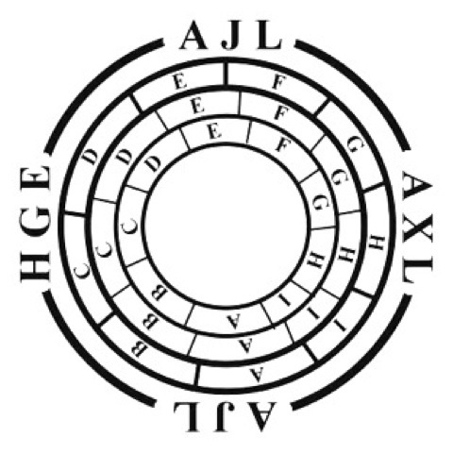

XXXII International Congress of the Asociación de Jóvenes lingüistas
(‘Young Linguists Association’)
9th, 10th and 11th November 2017 – Seville (Spain)
Attendance form
(This application form must be sent to ajlsevilla2017@us.es)

Personal Details:

Name |  | Surname
ID Number
Address
Postcode |  |  |  | Country
Telephone  (with country code) |  |  |  | Email
University or Institution

Would you like to attend the congress dinner on Friday 10th November 2017? Yes ☐ No ☐

